1. Deploy the custom image with any application installed.

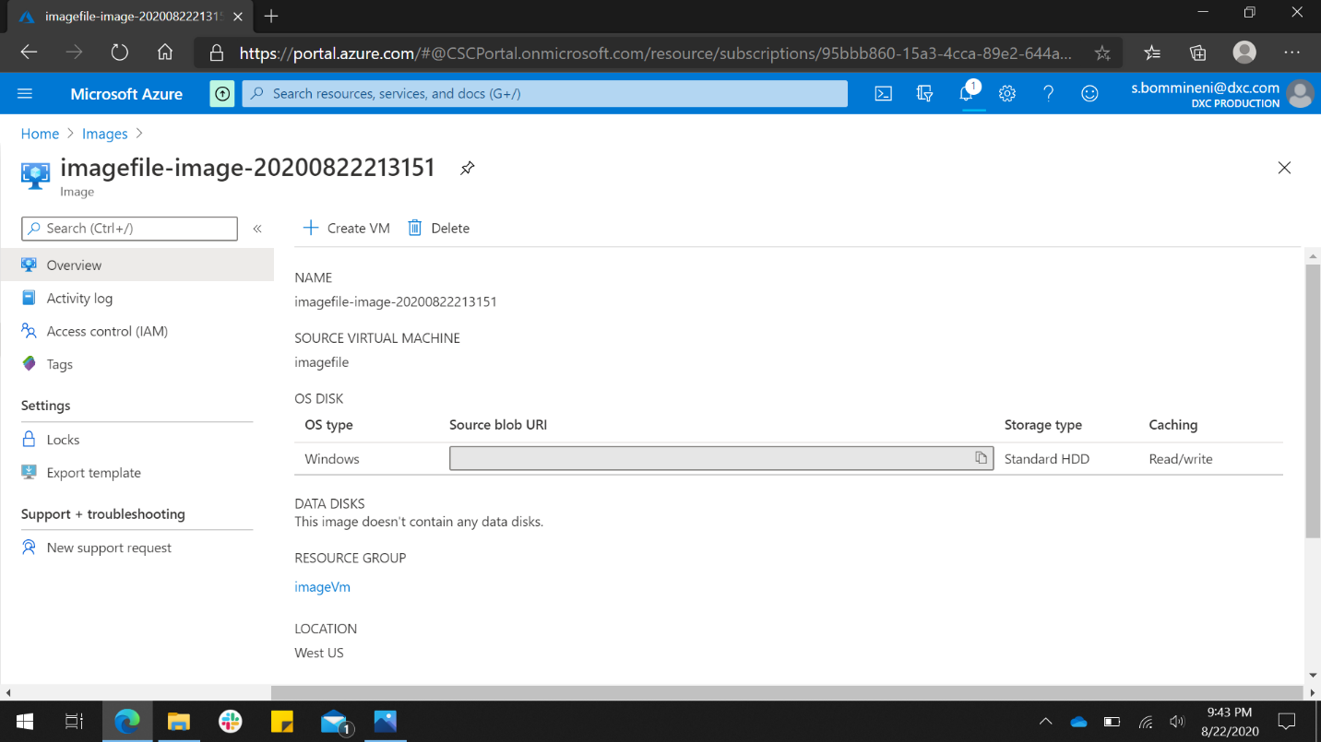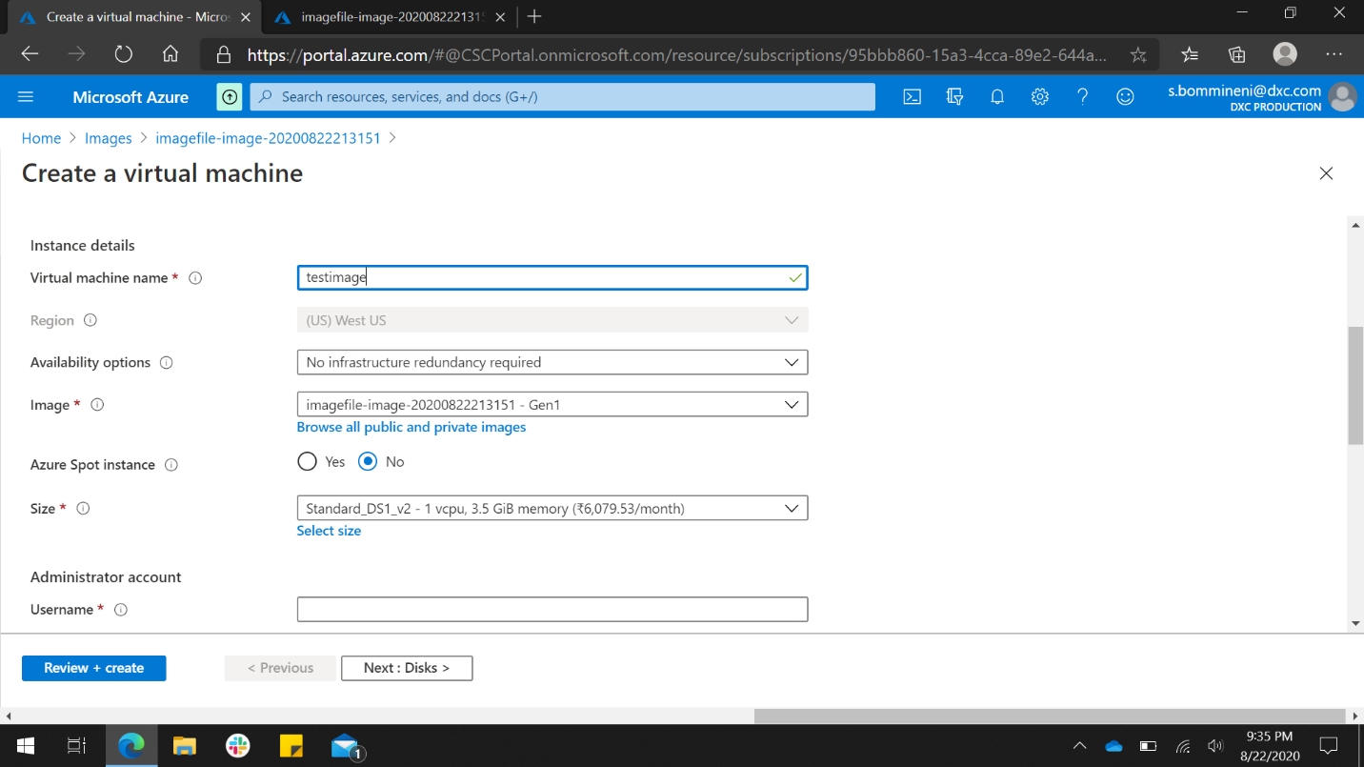

I have created image of an VM with notepad ++ installed and next I have created a VM with the image created. The new VM created is having the notepad ++ pre-installed.

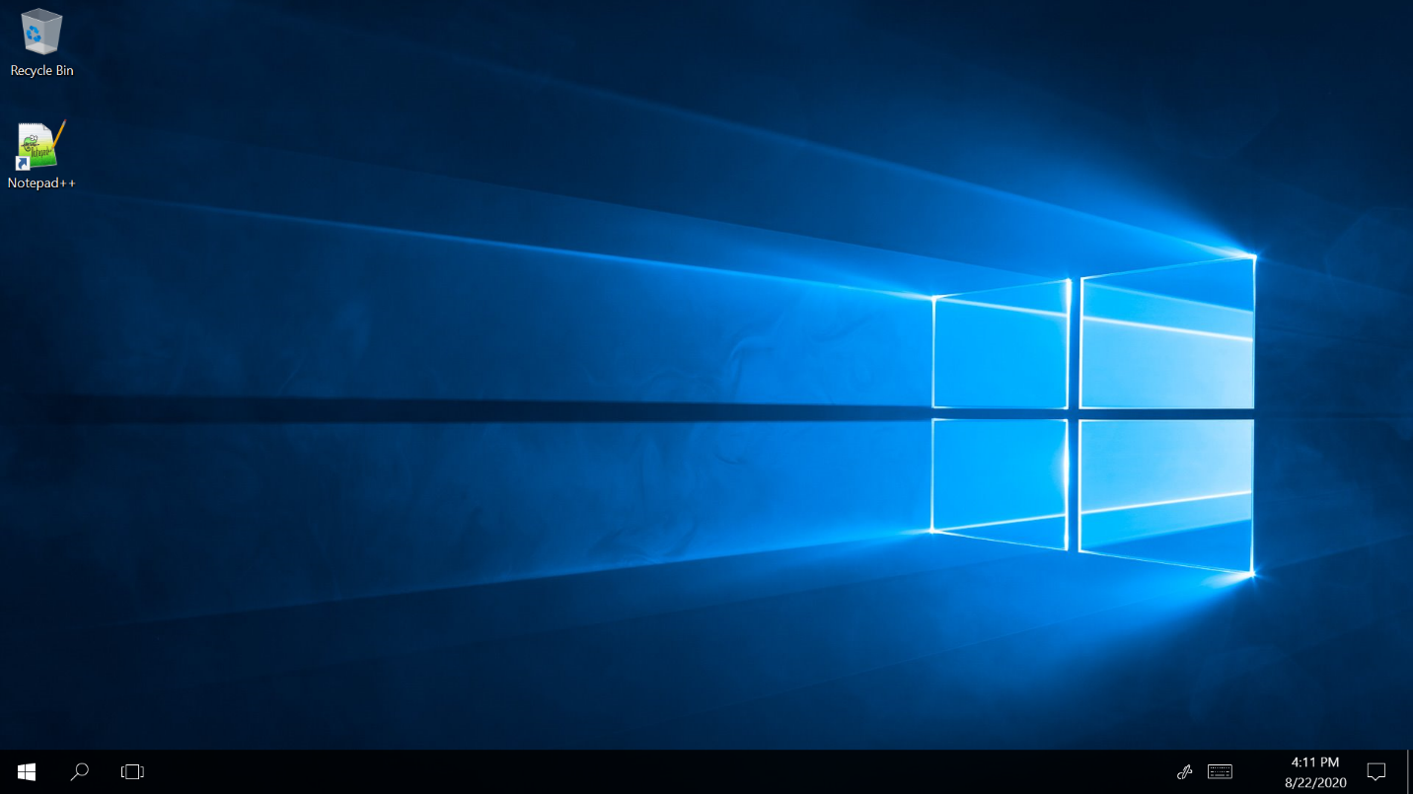

1. Create two networks in east Asia and West us and peer the network using Network peering and access the VM using private from one location to other location.

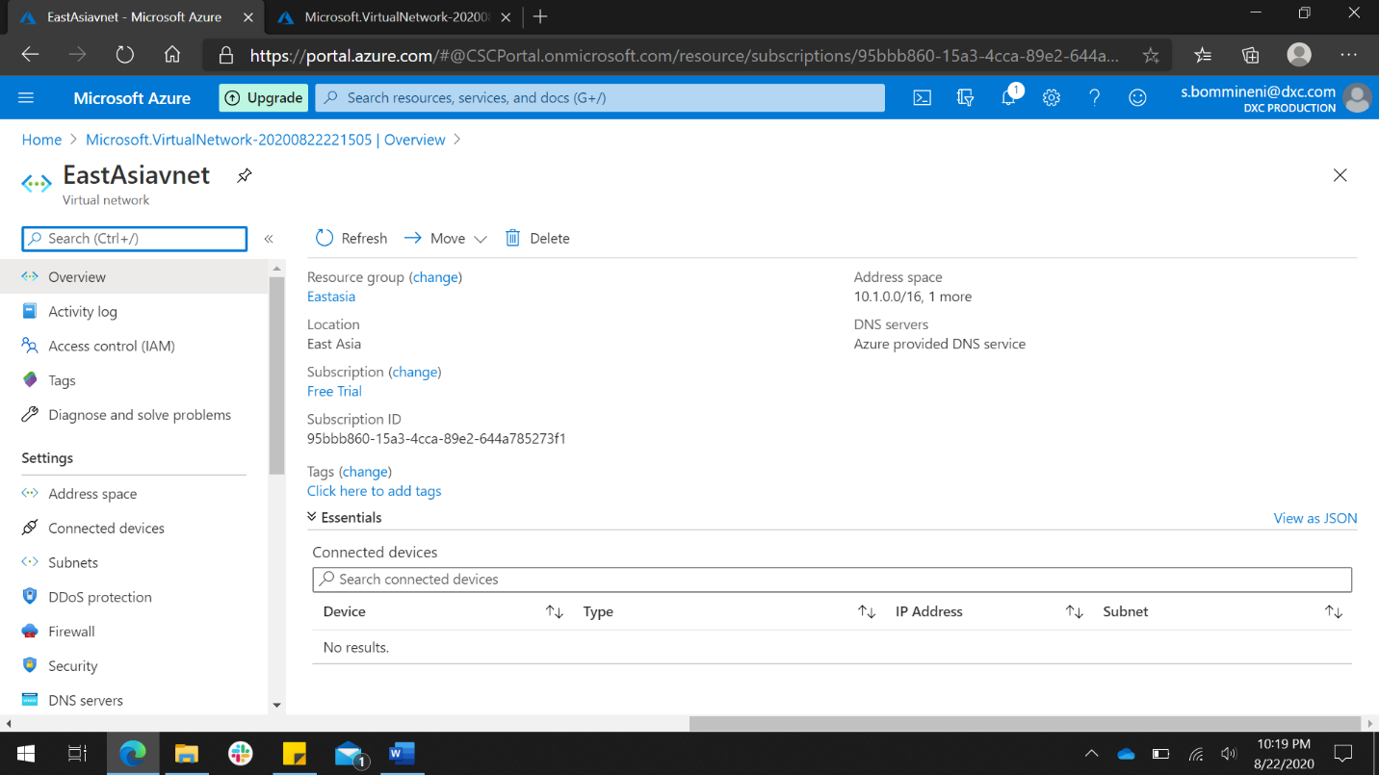

I have created two vnet’s (along with two VM’s) one in East Asia and the other in West us and enabled peering between them.

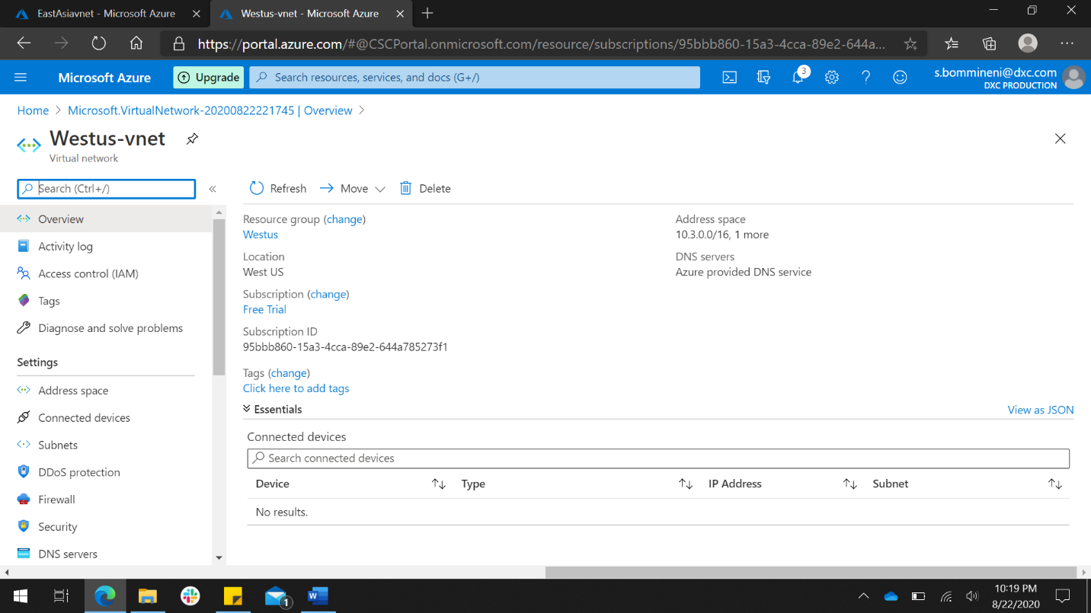

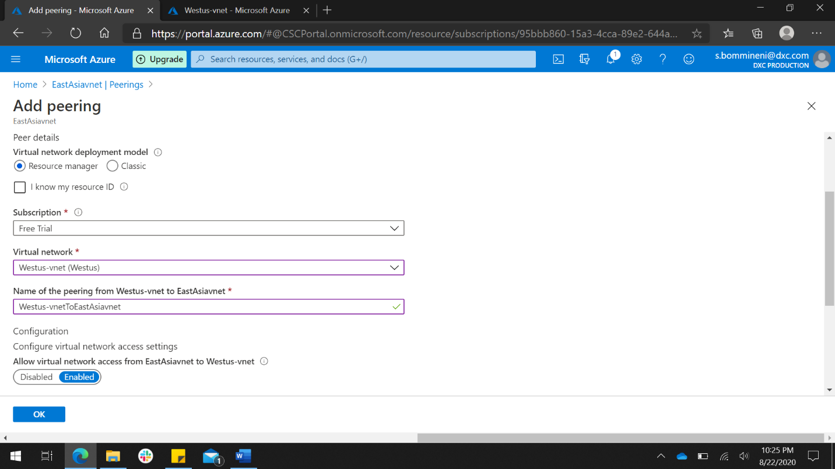

After enabling peering between two vnet’s I have connected to VM in East Asia and accessed VM in West us using public ip of West us.

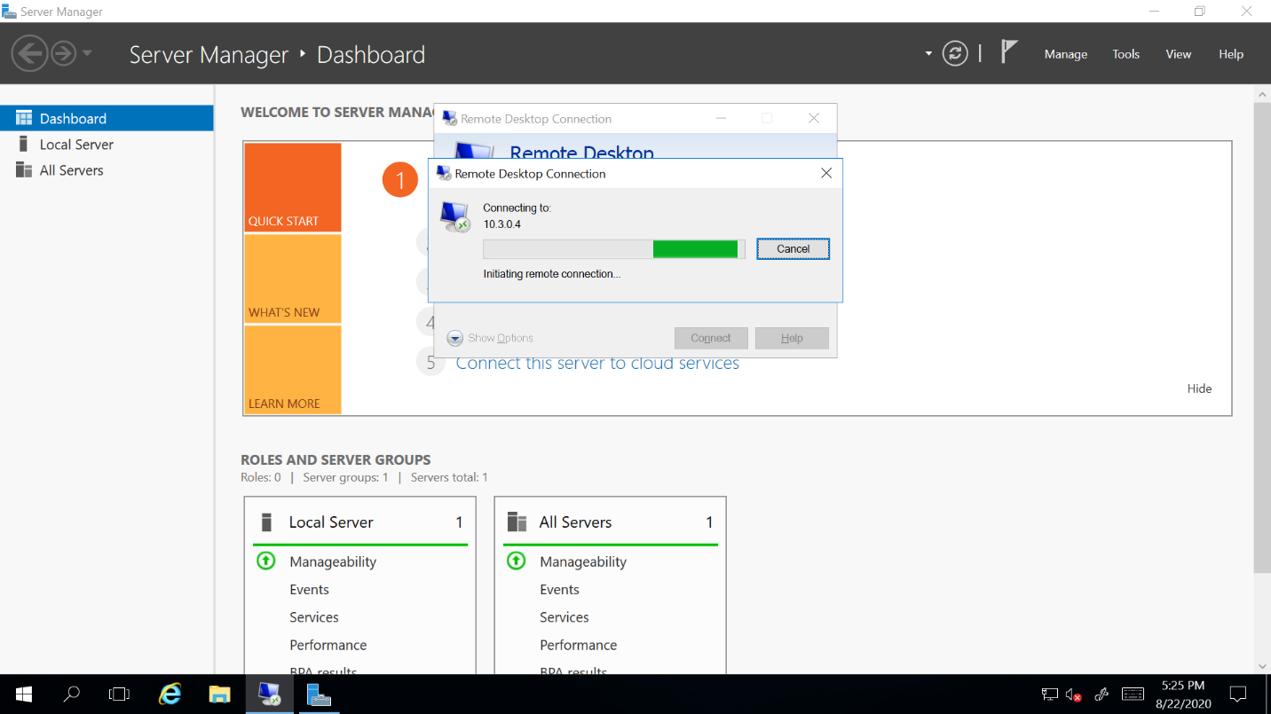

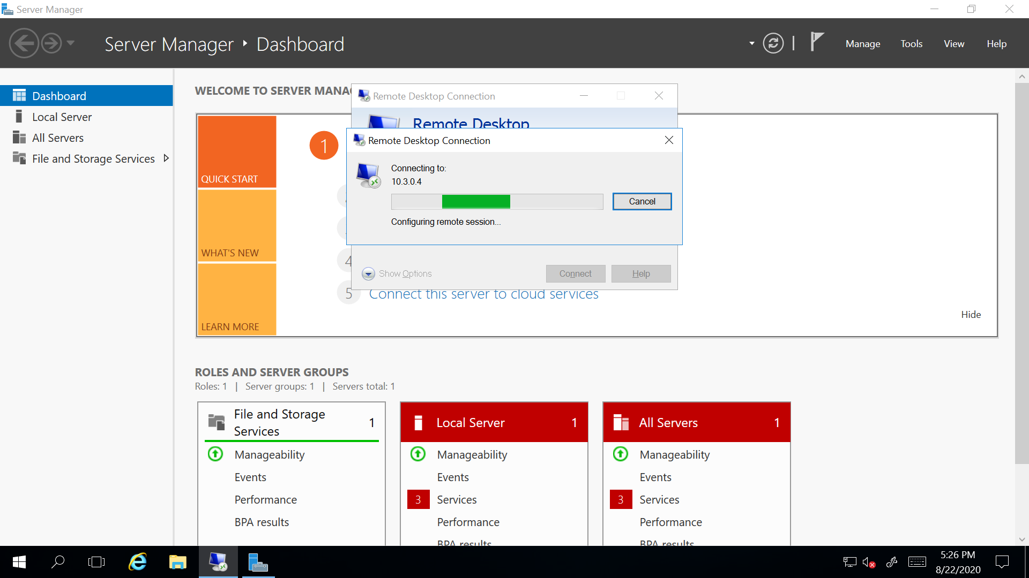

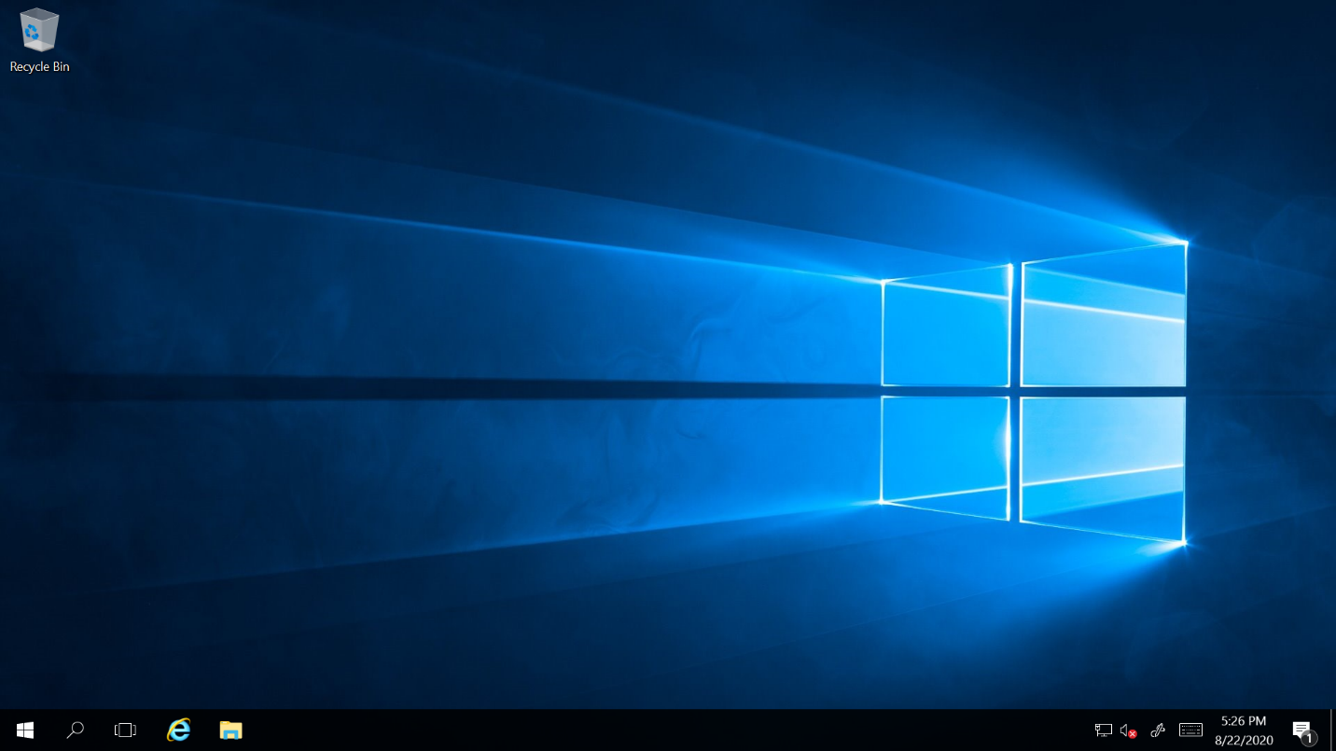

1. Create a point to site VPN in west us location and try connecting from your location laptop to Azure datacenter.

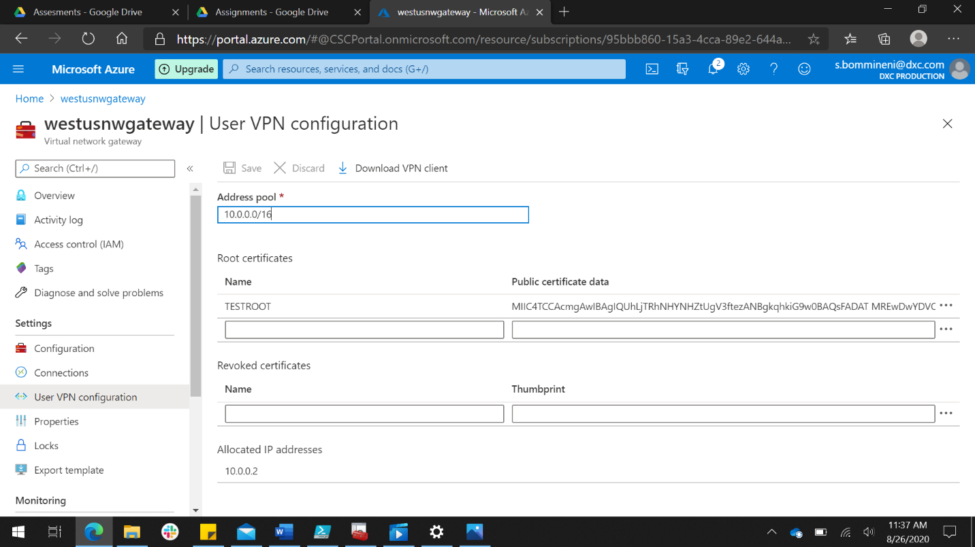

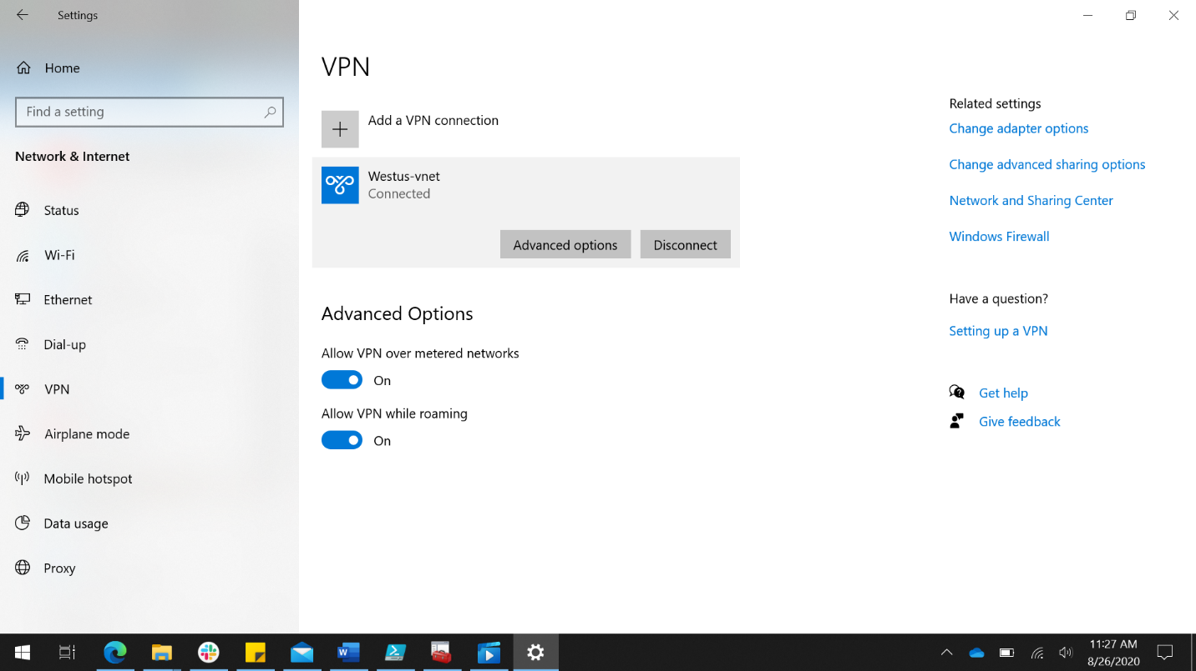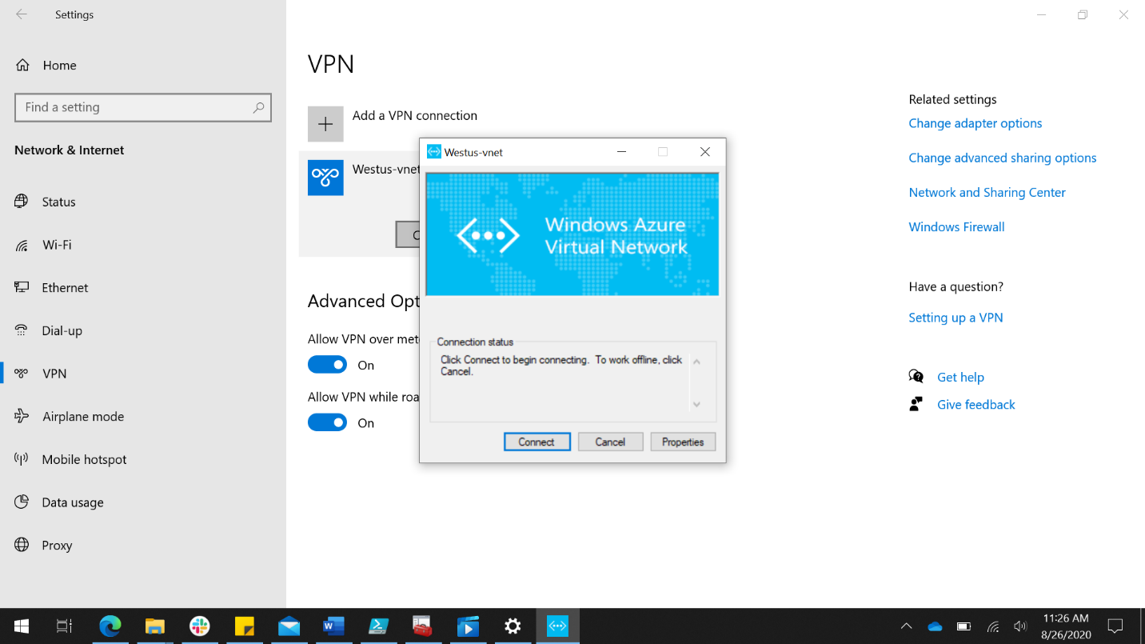

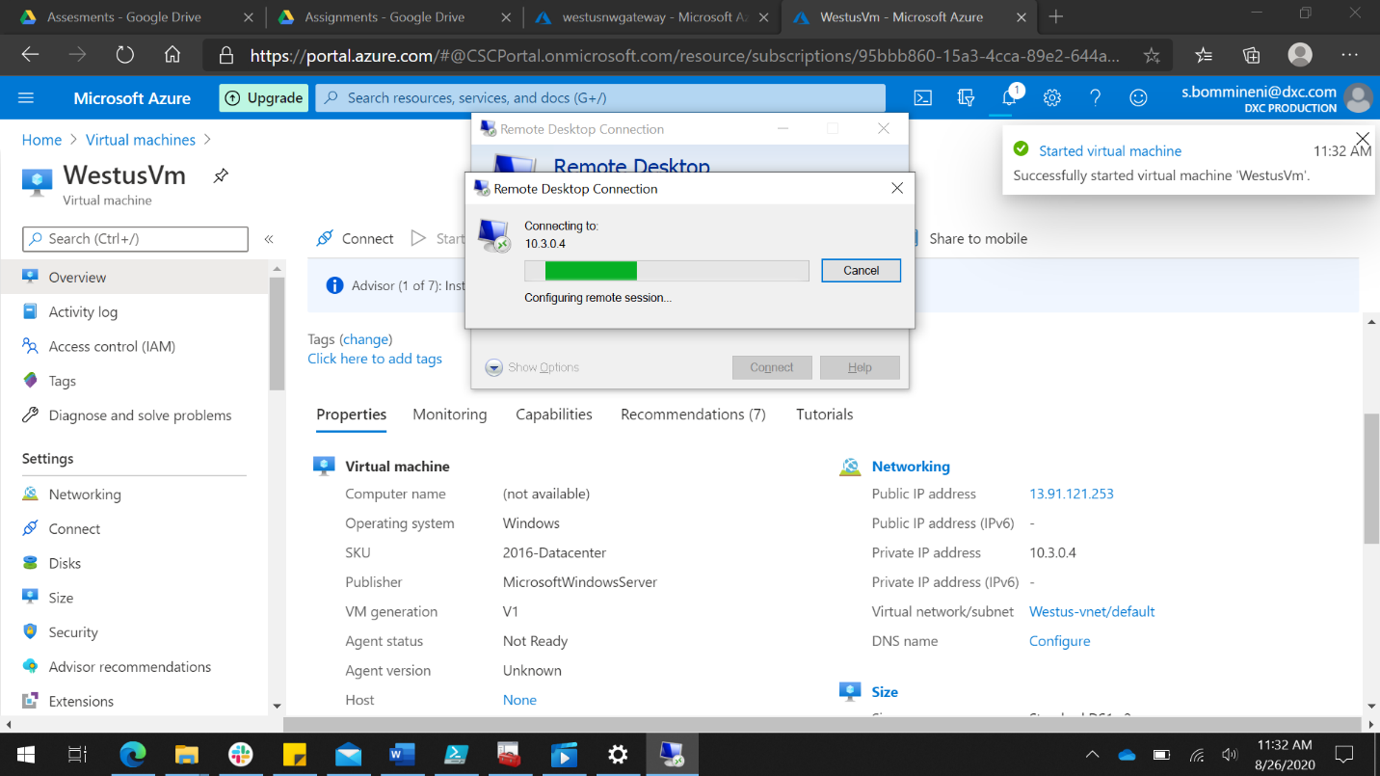

I have connected to VPN and using private ip I have connected to VM.

1. Create two Web applications and put the apps under traffic manager with priority routing method.

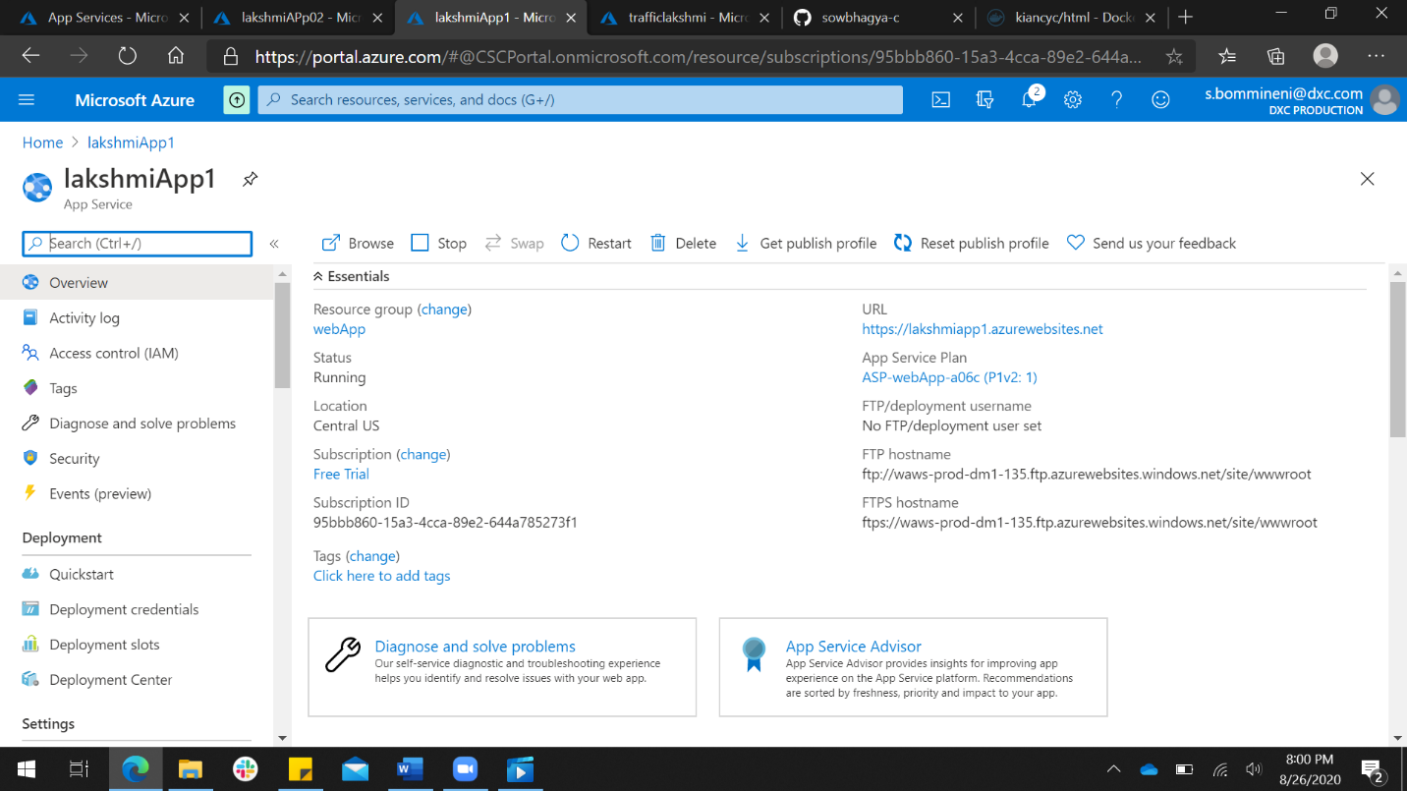

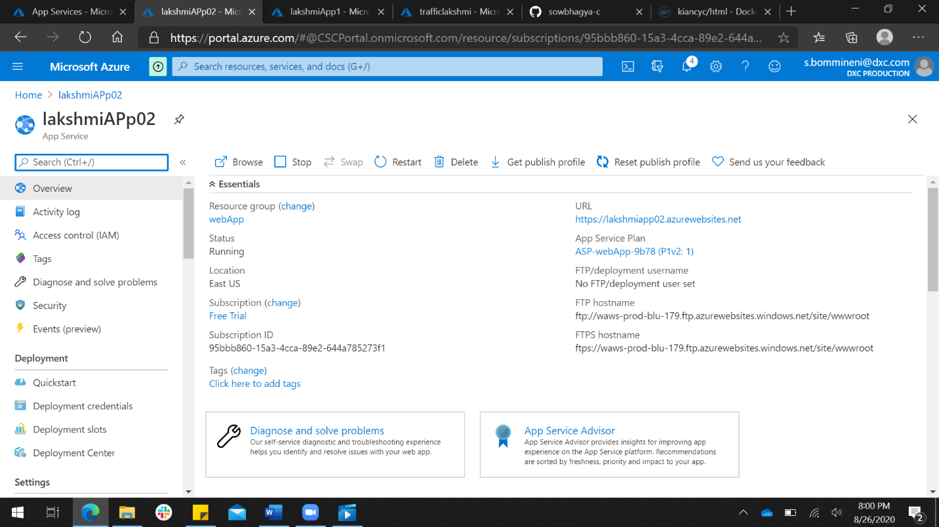

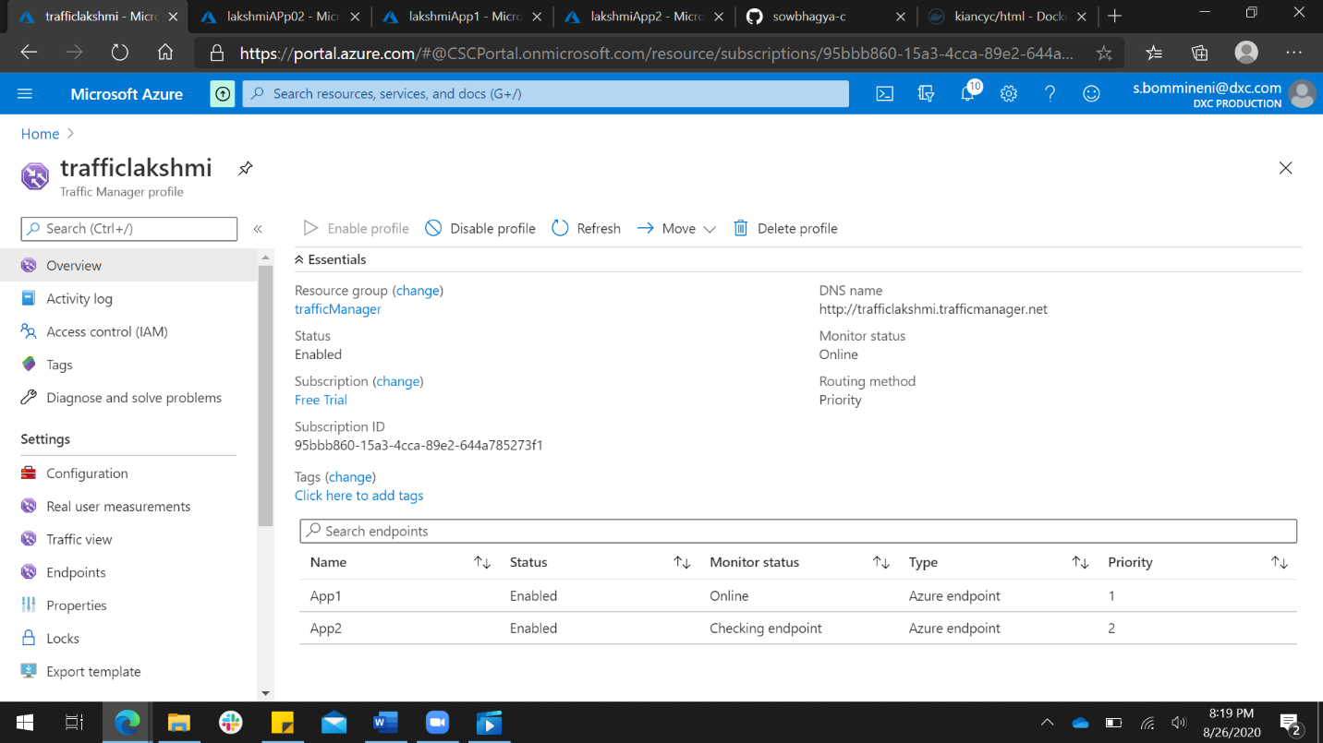

1. Create a backup solution for the VM and assign daily policy to the VM with 10 days retention period.

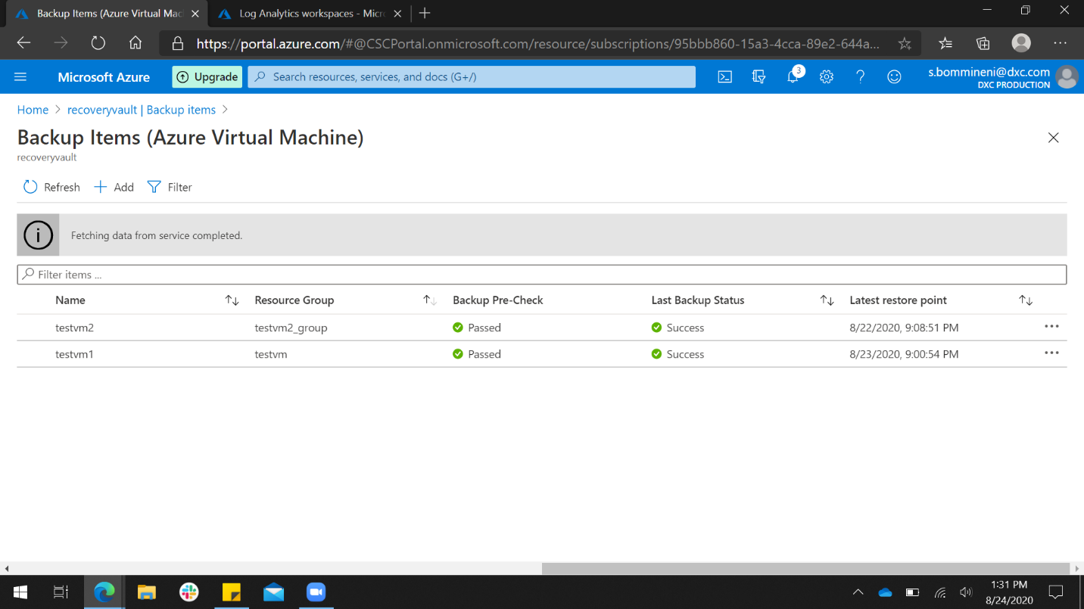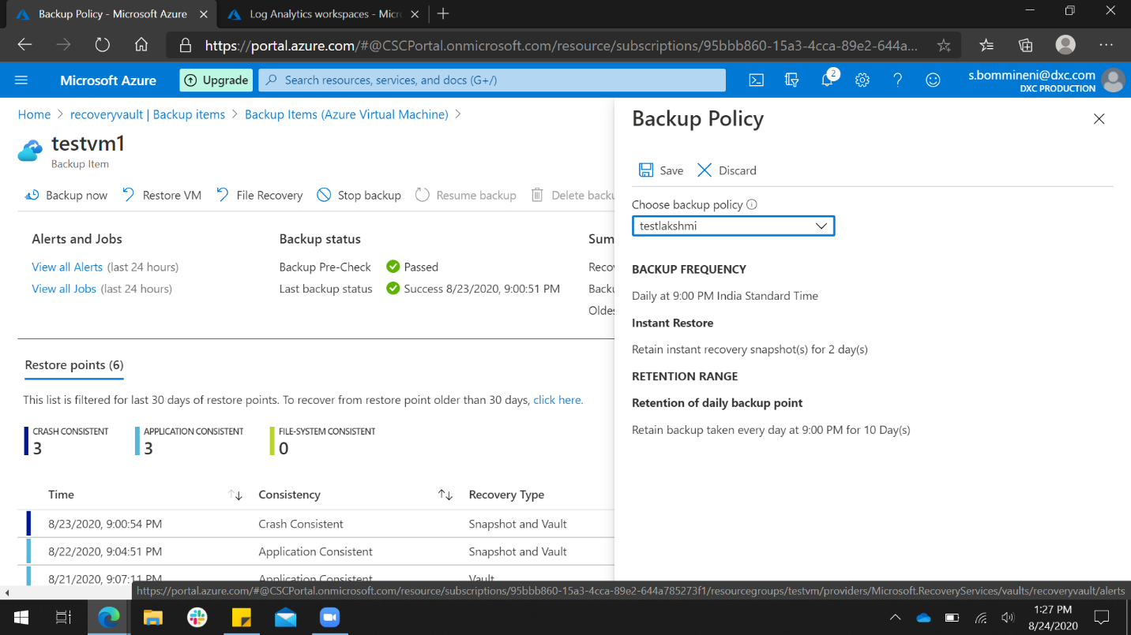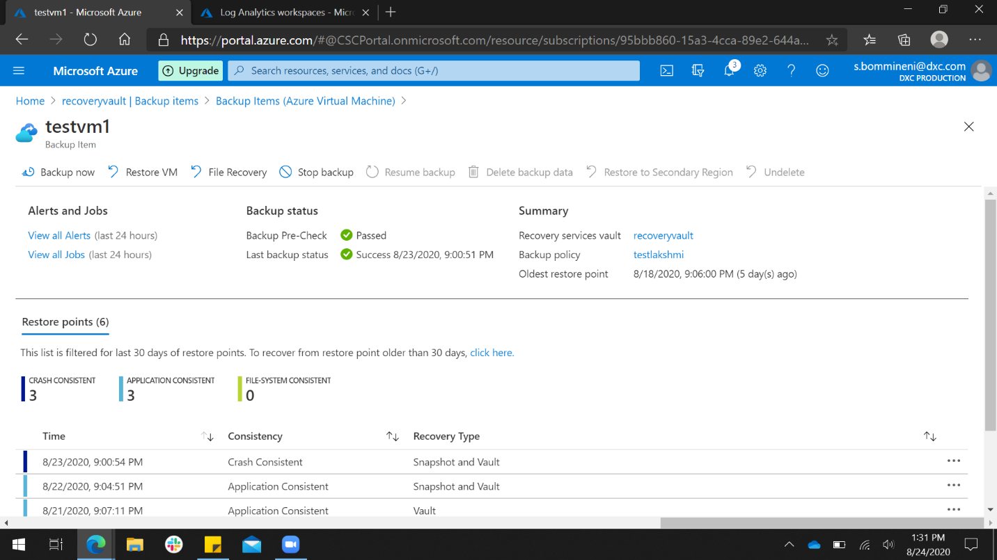

1. Replicate the VM from West us to any location using failover.

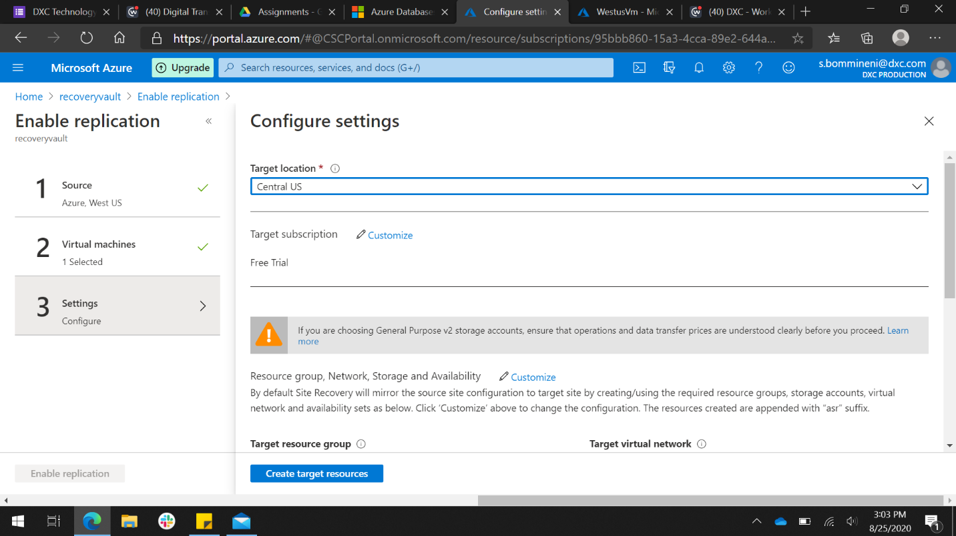

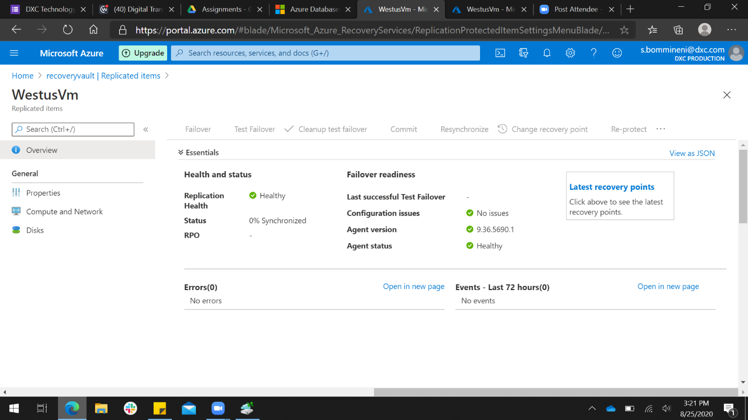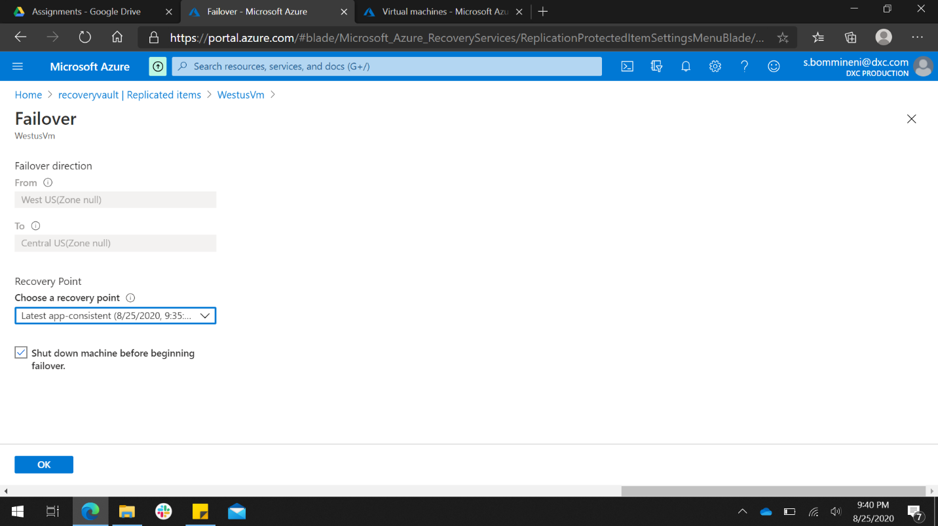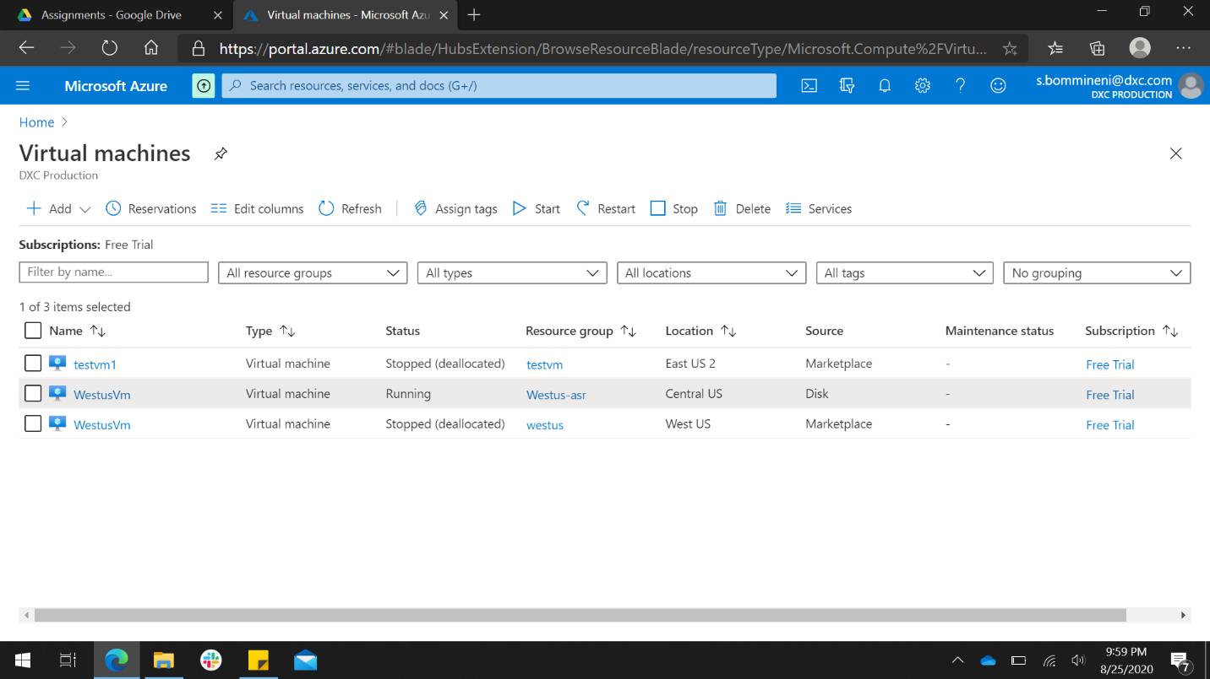

1. Take a on-premises backup using backup agent and exclude test folder from any drive.

